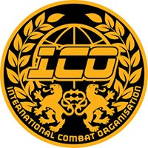

KICK LIGHT (Low kick) Rules in brief.
KICK LIGHT is the same as normal continuous rules with kicks above the waist, the only difference is competitors are allowed to use low point round kick.
Low point round kick is allowed to the inner and outer thigh only! No attacks to the joints or below the knee, this will be classed as a foul and will result in warnings or disqualification.
This is Kick Light so competitors are not looking to finish the fight with low kick but to score points with the extra weapon they have to use.
There is no catching or grabbing of the legs allowed in Kick Light, deflecting the leg to spin or off balance opponent is allowed.
Good control of all techniques must be used any excessive force will be penalised!
Equipment required = 10 oz Boxing gloves (full size! NO small condensed kids 10 oz allowed!), Head guard, Mouth guard, Groin guard, shin and instep pads, No spin kicks to head allowed due to heel not being covered.
Clothing = Shorts Only - Thai or MMA type (NO! football or other sport type shorts allowed!)
Club or Association T shirt (again NO Nike or Reebok type T - shirts!)
ALL Equipment and Clothing must be clean and in good order and the right type, it must also fit correctly, Officials have the right to refuse entry or disqualify any competitor if these rules are not abided by.
WARNINGS= VERBAL WARING, VERBAL WARNING, YELLOW CARD (MINUS POINT) RED DQ!
Officials have the right to jump levels should they deem it necessary!

