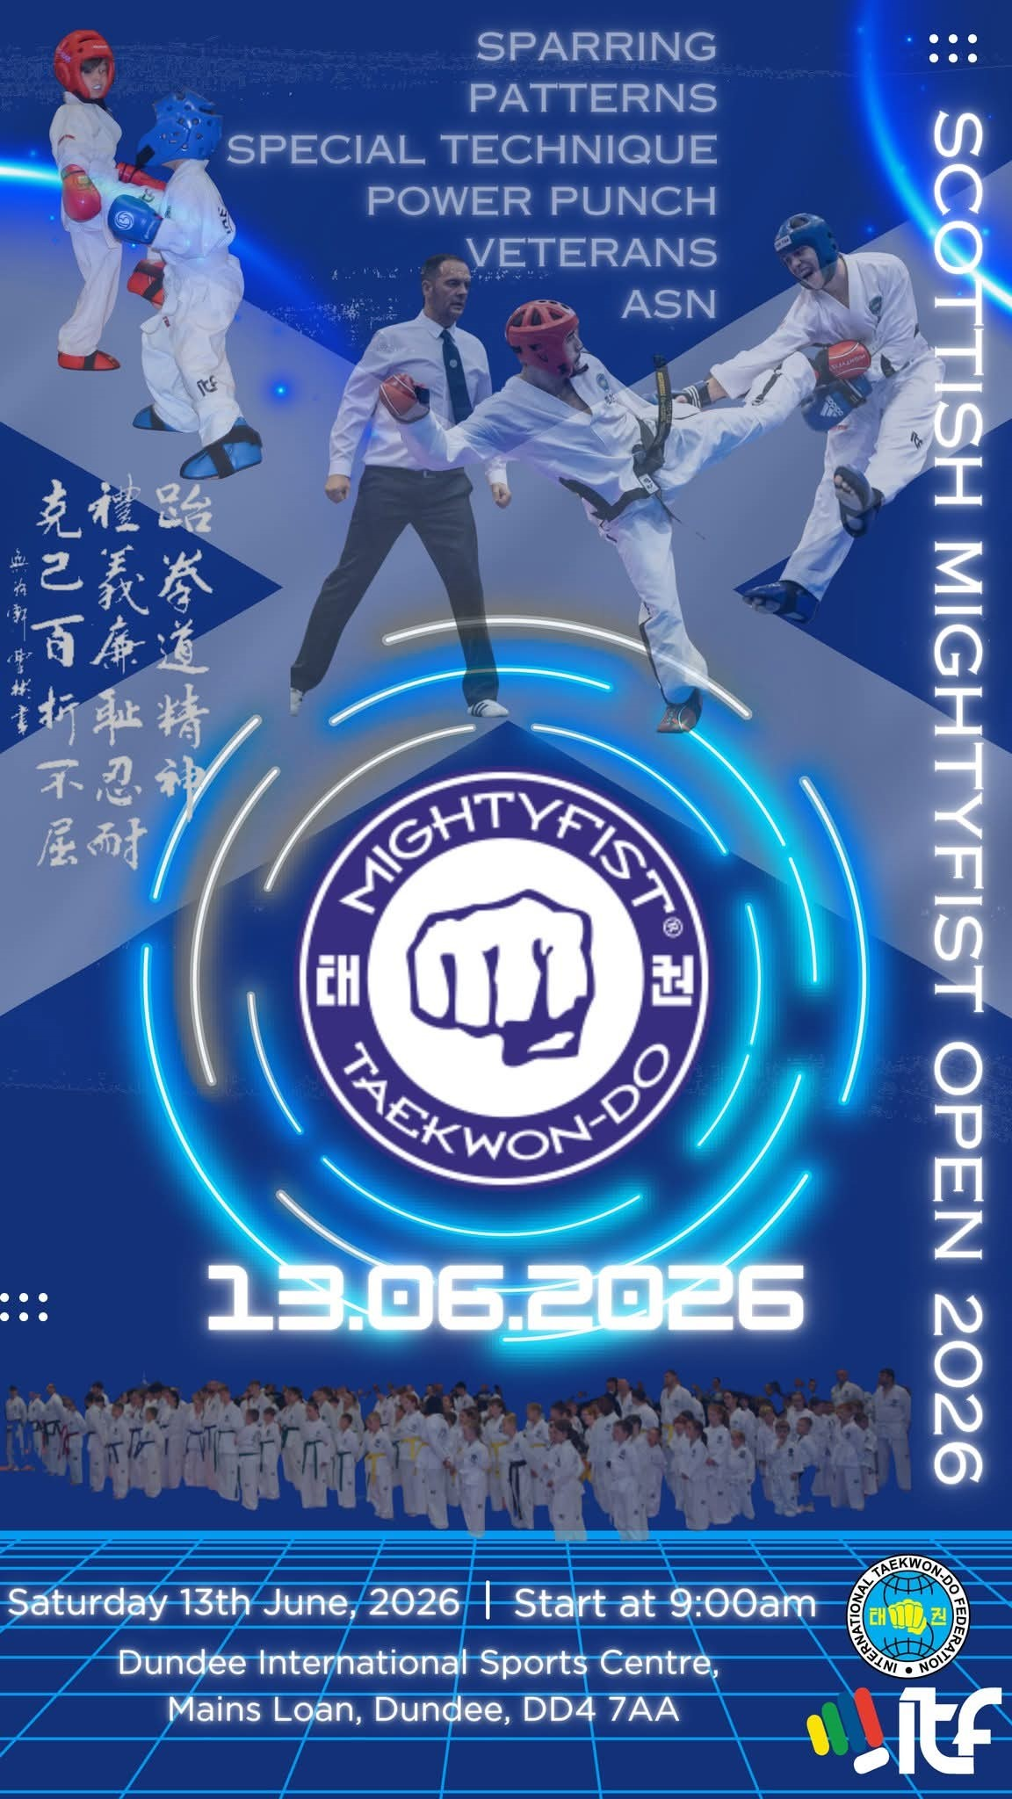
THE MIGHTY FIST OPEN, 2025.
Dear Grandmasters, Masters & Instructors,
We are delighted to invite you and your members to the 2nd edition of the Mighty Fist Open.
This open championship is for ITF Taekwon-do students from 10th Kup to 6th degree.
Please read and distribute this invitation to your members.
We look forward to seeing you all at our new venue; Dundee International Sports Centre, Mains Rd, Dundee DD4 7AA.
We are proud to bring this competition to you in association with our sponsors, Mighty Fist Scotland.
Mighty Fist is the official global sponsor of the ITF and we are the official Mighty Fist distributor for Scotland.
For all your ITF equipment, please visit www.mightyfistscotland.com.

Yours sincerely,
Master D McNairn VIII Degree
Master R Blair VIII Degree
Master D Lupton VII Degree.
DATE AND VENUE.

The Mighty Fist Open will be held on Saturday 13th June 2026.
The venue is the Dundee International Sports Centre, Mains Rd, Dundee DD4 7AA.

COMPETITION REGISTRATION.

This year, the Mighty Fist Open are delighted to inform you that this competition will be run with the assistance of our friends at Kihapp.com, tournament registration specialists.

This system takes the hassle out of tournament registration, making it paper free and easy for the competitors and instructors!
Registration is recorded directly to Kihapp.com website, where you will be directed to the Mighty Fist Open competitions own site. Once the instructor has registered their Taekwon-do school, all the competitors must do is fill in their details (height, weight, grade, disciplines etc.). Payment will also be made during registration.
Please visit their website at kihapp.com for more information.

CONDITIONS OF REGISTRATION-OFFICIALS.

UMPIRES.
Each school should supply the following umpires to competitor ratio;
1-5 competitors = 1 umpire
6-10 competitors = 2 umpires
11-20 competitors = 3 umpires etc.

Please supply as many umpires as possible to ensure a high level of refereeing on the day. All umpires will be provided with refreshments and snacks during the competition.
Please ensure that all umpires are registered at Kihapp.com/Mightyfist Open competition site (look for “referees” on the header).

Umpires must wear the correct attire for official ITF competition:
Navy trousers, navy jacket, white long sleeved shirt, navy tie, white training shoes and white sports socks.

COACHES.

It is permitted to have a coach present at the competition, provided the club meets the umpire to competitor ratio. They may have the following number of coaches.
1-5 competitors=1 coach,
6-15 competitors= 2 coaches,
16-30 competitors=3 coaches etc.
No more than 5 coaches are permitted.
A coach must be a training and licenced member of your school. PLEASE NOTE NO BLACK BELT COACHES OVER THE AGE OF 18.
The coaches must be dressed in appropriate attire (club tracksuit and t-shirt), carrying a towel and surgical gloves at ringside.
All coaches must have registered at the kihapp.com/Mighty Fist Open competition site (look for coaches on the header).
A coaching pass will cost £5 per coach. No registration will be permitted on the day of competition.

NB: All Coaching passes will be issued on the morning of the competition.

COMPETITORS PLEASE NOTE:
NO ENTRIES OR PAYMENTS FOR THIS COMPETITION WILL BE ACCEPTED ON THE DAY OF COMPETITION.
PLEASE ENSURE THAT ALL COMPETITORS ARE REGISTERED AT KIHAPP.COM. FOR THE DEADLINE OF SATURDAY 6TH JUNE 2026.
REGISTRATION, WEIGHT & HEIGHT CHECK.

It is the instructor’s responsibility to ensure that their students’ details are correct and that they have been registered correctly and placed in the appropriate division. Instructors should scrutinise their student’s information prior to the event registration. This can be done in the Kihapp system online.

SAFETY EQUIPMENT.
Compulsory equipment
• Open palm sparring gloves
• Foot protection
• Head protection
• Gum shield (Clear)
• Groin guard (Males only)
Optional Equipment
• Body Armour (10 years and under)
• Shin guards
• Chest Protectors (Female)
• Groin Guard (Female).

COMPETITION RULES.

ITF rules will apply with modifications to suit age, experience, and gender.

COMPETITION ENTRY FEES.

Competitors £40
Coaches £5
Spectators £5

DIVISIONS AND CATEGORIES.

AGE GROUPS:
The competition will be divided into the following divisions:
    - POWER PUNCH (3-6 yrs).
    - YOUTH (7 years & above)
    - ADDITIONAL SUPPORT NEEDS.
    - CADET (8 – 11 years)
    - PRE-JUNIOR (12 – 14 years)
    - JUNIOR (15 – 17 years)
    - SENIOR (18 – 35 years)
    - ADV SENIOR (36 years & over)

GENDER.
All categories will be split male and female.

NB. THE COMPETITION ORGANISERS RESERVE THE RIGHT TO MERGE DIVISIONS TO ENSURE FAIR OPPORTUNITY TO ALL COMPETITORS.

PATTERNS.

COLOUR BELTS
all competitors will perform one optional pattern according to their grade:
• White Belt: Saju-Jirugi / Saju-Makgi / Chon-Ji
• Yellow Belt: Dan-Gun / Do-San
• Green Belt: Won-Hyo / Yul-Gok
• Blue Belt: Joong-Gun / Toi-Gye
• Red Belt: Hwa-Rang / Choong-Moo.

PATTERN – ADDITIONAL SUPPORT NEEDS.
In each division the competitors will perform one optional pattern from Saju-Jirugi to their respective grade.

BLACK BELTS.

All competitors will perform one designated pattern
according to their grade:
• 1st Degree: Kwang-Gae / Po-Eun / Ge-Baek
• 2nd Degree: Eui-Am / Choong-Jang / Juche
• 3rd Degree: Sam-Il / Yoo-Sin / Choi-Yong
• 4th – 6th Degree: Yong-Gae / Ul-Ji / Moon-Moo.

In the final, the competitors perform two designated patterns:
The first designated pattern will be randomly chosen from one of the three patterns appropriate to the category degree. The second designated pattern will be chosen from all the remaining patterns from Chon-Ji to their degree, excluding the one performed for the 1st designated pattern.
IN THE CASE OF A DRAW:
Both competitors will be given a designated pattern from Chon-Ji up to the limit of the lowest grade competing, excluding any pattern that was performed in the first pattern. White belts may perform the same pattern again.

SPARRING.

HEIGHT CATEGORIES.
YOUTH <120cm, <130cm, >130cm
CADET <130cm, <140cm, <150cm, >150cm
PRE-JUNIOR <150cm, <160cm, <170cm, >170cm.

COLOUR BELT GROUPS FOR HEIGHT DEFINED CATEGORIES

YOUTH, CADET AND PRE-JUNIOR will be split both MALE and FEMALE with following belt colour groups:
• White – Yellow Belt
• Green – Blue Belt
• Red - Black Belt.

WEIGHT DEFINED CATEGORIES.

JUNIORS will compete in the following belt colour groupings:
• White – yellow Belt
• Green -Blue belt
- Red Belt
• Black Belt
The following weight categories will apply for Junior Kup Grades.

• Male <56kg, <68kg, >68kg
• Female <56kg, <68kg, >68kg

The following weight categories will apply for Junior Black Belts.

• Male <50kg, <55kg, <60kg, <65kg, <70kg, <75kg, >75kg
• Female <45kg, <49kg, <53kg, <57kg, <61kg, >65kg, >65kg.

The following open weight categories are optional (pre-registration only. Athletes cannot register on the day of the event).

• Male Black Belt 15-17 years
• Female Black belt 15-17 years.
SENIOR and ADV SENIOR will compete in the following belt colour groupings:
  - White – Yellow belt
  - Green Belt
  - Blue- Red Belt
  - Black Belt
The following weight categories will apply for Senior Kup Grades.

• Male <63kg, <78kg, >78kg
• Female <55kg, <65kg, >65kg.

The following weight categories will apply for Senior Black Belts.

• Male <57kg, <63kg, <69kg, <75kg, <81kg, <87kg, >87kg
• Female <50kg, <55kg, <60kg, <65kg, <70kg, <75kg, >75kg

SPARRING FORMAT.

All coloured belt categories will be contested in a traditional pyramid system, in continuous sparring format. There will be no point stop sparring.

All Junior & Senior Black Belt Sparring Categories will be contested in League format, with a two-minute round. In the case of Final’s these with be contested as 2 rounds of 2 minutes.

SPARRING MATCH DURATION.

All time periods are for elimination rounds and finals. All matches if resulting in a draw will conclude in a 1st point (Golden Point)
deciding round.

YOUTH.
All grades will be 1 x 60 secs.

CADET & PRE-JUNIOR.
All grades will be 1 x 90 secs.

ASN competitors.
All grades will be 1 x 90 secs.

JUNIOR.
Kup Grades will be 1 x 120 secs.
Black Belts will be 1 x 120 secs. (Leagues)
Black Belt Finals will be 2 x 120 secs with a 60 sec rest period.

SENIOR.
Kup Grades will be 1 x 120 secs.
Black Belts will be 1 x 120 secs. (Leagues)
Black Belt Finals will be 2 x 120 secs with a 60 sec rest period.

ADV SENIOR.
Kup Grades will be 1 x 120 secs.
Black Belts will be 1 x 120 secs.

SPECIAL TECHNIQUE.

CATEGORIES DEFINED BY HEIGHT.
All grades will merge White-Black according to their sparring heights. Male & female gender splits will still apply.

• YOUTH <120cm, <130cm, >130cm
• CADET <130cm, <140cm, <150cm, >150cm
• PRE-JUNIOR <150cm, <160cm, <170cm, >170cm.

All competitors will perform the following technique:
• Nopi Chagi

The starting target height of all height defined categories will be 10cms above category height eg <120cms will have a starting height of 130cms

JUNIOR, SENIOR, ADV SENIOR COMPETITORS.

Competitors will compete in the following Belt Groupings:
• White to Red Belt
• Black Belt.

Kup Grade competitors will perform the following technique:

Twimyo Nopi Ap Cha Busigi
Jnr (Target Height 210cms M; 200cms F)
Snr (Target Height 220cms M; 210cms F)

• Twimyo Nopi Ap Cha Busigi
Jnr (Target Height 240cms M; 210cms F)
Snr (Target Height 250cms M; 220cms F)
Adv Snr (Target Height 220cms M; 190cms F)

PERFORMANCE NOTES.

The attempt is measured simply by break or no break. There will be no levels of scoring as the machines do not have a 90 or 45 deg stop to determine the 3 pt and 1 pt segments.

Each competitor will be allowed one measure and one attempt.
In the categories defined by height this rule can be interpreted as the
competitor is allowed two attempts to strike the target.

In the Junior, Senior and Adv Senior the competitors should follow the rule and only measure first. Should the Nopi Chagi be struck on what would be deemed to be the measure, no penalty will apply and a break will be assumed.

• Those successfully striking the target in the single Nopi Chagi event will progress into the next round whereby the target will be raised until a winner is found. If there are no successful breaks, no medals will be awarded. The minimum height for the category is the lowest height the target can go.

Medals will be awarded for 1st, 2nd, and 3rd place.

POWER TEST

This is only open to competitors 14 years and above, green belt and above in the following categories:

• Green to Red
• Black Belt

All competitors will compete using one hand & one foot technique. The board requirements as follows:

JUNIOR (14-17 years)

Female.
- Ap Palkup Taerigi (1 board)
- Yop Cha Jirugi (2 boards)

Male.
- Sonkal Yop Taerigi (2 boards)
- Yop Cha Jirugi (2 boards)

SENIOR (18-35 years)

Female
- Ap Palkup Taerigi (2 boards)
- Sonkal Yop Taerigi (2 boards)

Male.
- Sonkal Yop Taerigi (3 boards)
- Yop Cha Jirugi (4 boards)

The number of boards for each technique is set in advance of the
tournament, according to the tables above.

For each board broken or full separation, 3 points will be awarded.
For each bent board 1 point will be awarded. The winner will be the athlete who has accrued the most points.

The three highest scores will set 1st, 2nd and 1 x 3rd place. (*Only in the event there are two tied in 3rd place with the same score in the same round will 2 Bronze medals be awarded).

Accomodation

For those wishing overnight accommodation, Dundee has a wide selection of budget hotels and apartments as well as quality branded hotels.
Check out www.Booking.com for all your needs.

AIR LINKS.
Aberdeen International Airport (67 miles).
Edinburgh international Airport (60 miles).
Glasgow international Airport (89 miles).

CONTACT
Please do not hesitate to contact anyone in the organising committee should you have any questions or require any assistance registering for the event, hotel assistance etc.

We look forward to welcoming you all to Dundee.

Master D McNairn VIII Deg dmcnairn@aol.com Tel: 07831 575652
Master R Blair VIII Degree rblairtkd@sky.com Tel: 07852 969245
Master D Lupton VII Degree dlupton@sky.com Tel: 07523 856029

