WUKF NW Traditional Martial Arts and Kubodu League and Provincial Challenge.


September and November 2026

Dear WUKF and MASA-affiliated members.

Welcome to the championships. It will be an honor to work with you. We appreciate your cooperation in maintaining a fair and consistent application of the rules for everyone. In order for the WUKF rules to be more suitable for these circumstances, we have tweaked some of the rules a little bit. Here is a summary of the rules (as also stated in the invitation) with emphasis on the most important rules that must be complied with.

Kind regards
Vickus van Dyk
Event Director

Compulsory equipment for WUKF NW Provincial Championships:
• Mitts for all Kumite categories. Competitors must use bubble mitts, with or without a thumb protector. Competitors may use WUKF-approved Shobu Ippon mitts.
• For Junior, Senior, and Veteran elite (red, which is after purple, brown, and black belt) categories: the competitors must have the correct colour mitts, depending on being Aka of Shiro. The rest will only be required to have one pair of mitts (red or white).
• Material mitts are not allowed as they are hard and do not provide sufficient protection.
• Gum shields must be worn for all Kumite. Except when a child wears a helmet. Any colour except red, although preferably white or clear will be permitted.
• Groin protectors (cadet, junior, senior, and veteran male Kumite). We will be flexible on this as not all competitors are likely to have a groin protector. Injuries incurred due to a competitor not wearing a groin protector will not necessarily result in a penalty for the opponent.
• White or red belts for Kumite, according to side. A limited number of belts will be provided, please do not remove them from the floor. The correct length would not be guaranteed.
• As far as possible, competitors in Elite categories should strive to wear the correct Karate-Gi and belt length, to set an example to younger competitors.
• Only White Karate-Gi are allowed. Black is permitted for Kobudo.

Optional
• Chest protectors for females from age 13 years (from Mini-cadets), must be white. It is a breast protector and not a body protector. It is highly recommended to wear it. Also, wear a white t-shirt.
• Groin protectors (for all male Kumite - but recommended).
• Body protectors (Children Nihon Kumite). May be worn inside or over a karate-gi jacket.
• Helmets (Children Nihon Kumite).

Allowed Equipment
• Sport glasses, spectacles, and contact lenses are worn at their own risk during Kata.
• Specially designed sports glasses may be worn with special permission and on completion of an indemnity form.
• Red or white shin protectors (Nihon and Sanbon Kumite).
• White instep protectors (Nihon and Sanbon Kumite). Red instep allowed for AKA.

Forbidden Equipment:
• Spectacles (glass or hard plastic) for Kumite.
• Instep and shin protectors for Ippon Kumite
• Blue mitts or blue shin protectors or insteps will NOT be allowed at all.
• The instep and shin protector must be separate, in two pieces, not one piece.
• Other world karate bodies’ logos on any equipment (mitts, Karate-Gi, protectors) must be removed or coloured over with a marker pen to ensure that it is not visible.
• Body protectors (except for Children Nihon Kumite).
• T-shirts (except for Females & Inclusive categories: white only. Combat attacker black).

Coaches
One coach for every 10 athletes per Federation will be allowed. Only coaches who attend the official course/s will be accredited to coach at the Championship. Coaches must wear a tracksuit. A tracksuit top may however be substituted with a golf or t-shirt. Coaches must have an identification card, to be handed to the officials before each kumite match.
The match will not be postponed to give the Coach 2 minutes to change into the correct uniform, (Art 4.16), but s/he must still change before being allowed to coach.

Draw Sheets
• The Knockout Drawsheet System will be implemented for all Kumite categories.
• The points system will be used for all Kata and Kobudo categories.
• Only the Chief Table Official or Tournament Organiser may make changes to the Drawsheets, they are: Vickus van Dyk and

Number of rounds in Kata categories:
13 Competitors or more: 3 rounds: Elimination, Prelim & Finals.
12 or less Competitors: rounds 2 & 3 and not doing round 1 (Prelim & Finals) Kihapp might call it then 1st and 2nd round.
There will be a maximum of 6 Competitors in round 3 (finals).

Where categories have been combined, for example, senior ladies white to purple, all competitors will be given the option to repeat a kata in each round and/or tie. When 12 and 13 year olds are combined (although highly unlikely), they will do Shobu Sanbon.
Only the final round will be done for Team Kata with Tokui Kata of registered style. May repeat in the event of a TIE.

The jury table judges will inform all competitors at the start of each category as to the number of rounds taking place. Do not rely on the number of entries per category as they appear at present, as it might change. Prepare TIE Katas for Elite categories, others may repeat in the event of a TIE.
The Competitor must clearly announce the Kata name.
The Centre Referee repeats the Kata name to the TO and searches for the abbreviation on the list.
Communicate it to the TO. Check if it is a valid Kata, or else assist in changing the choice.
The Centre Referee repeats the Kata name and then the Competitor starts.

We will not follow rule 69.7: If all the competitors who compete in a tie situation are disqualified, each competitor must perform an imposed kata from the Shitei list of their Kata style.
If there is a TIE, another Kata must be done, one competitor at a time, (not together). Points must be given. If there is another TIE, flags will be used based on the last Kata.
The TOs will need to break the tie on Kihapp manually if resolved with flags. TOs will award the winner the highest score in the range and the loser the lowest score in the range (so, if the range is 5-7, the winner will score 7 and the loser will score 5). This will break the tie on Kihapp and move Kihapp on to the next screen. The original score will be used for the grand total.

Dress code for Referees, Judges, and Jury Table Judges
The official referees’ uniform is: • A navy-blue blazer (optional for younger Judges/Kansa) bearing two silver buttons • A WUKF badge • A white short-sleeve shirt • A red WUKF / continental tie. • Light grey trousers • Black socks covering 2/3rd of the Shin. • Black soft-sole shoes.
• Whistle.
Jury table judges may wear grey, black, or navy (or a combination thereof), in conjunction with a white blouse or shirt.

Whilst on the Tatami; Referees, Kansa, and Judges are not allowed to wear watches, rings, earrings, bracelets, pens, cell phones, tiepins, or other objects and may also not use their cell phones or congregate in groups and have conversations. Please sit on the chairs next to the tatami.

The Competitor’s Uniform
Competitors must be dressed exactly as per Articles 4.4 to 4.14 and ART 5 in the WUKF rules and with the above-mentioned allowances. Officials will ask the Coaches to assist the Novice and Intermediate groups in getting ready. Referees will be strict with the Elite groups to adhere to the WUKF and tournament rules.
Two minutes will be given to correct the Uniform; in Kata: before the competitor enters the tatami and in a Kumite match: before Hajime.

Special circumstances will be considered by the Referee Commission and must be applied for in writing.

Match time
Individual Children 1 minute 30 seconds, effective time
Mini-cadets 2 minutes, effective time
Cadets 2 minutes, effective time
Juniors 3 minutes, effective time
Seniors 3 minutes, effective time
Veterans 2 minutes, effective time
Ippon 2 minutes running time
Rotation Nihon Team Kumite 4 minutes, running time
Rotation Sanbon Team Kumite 6 minutes, running time
Rotation Ippon Team Kumite 4 minutes, running time

27. Summary of Kata Rounds:

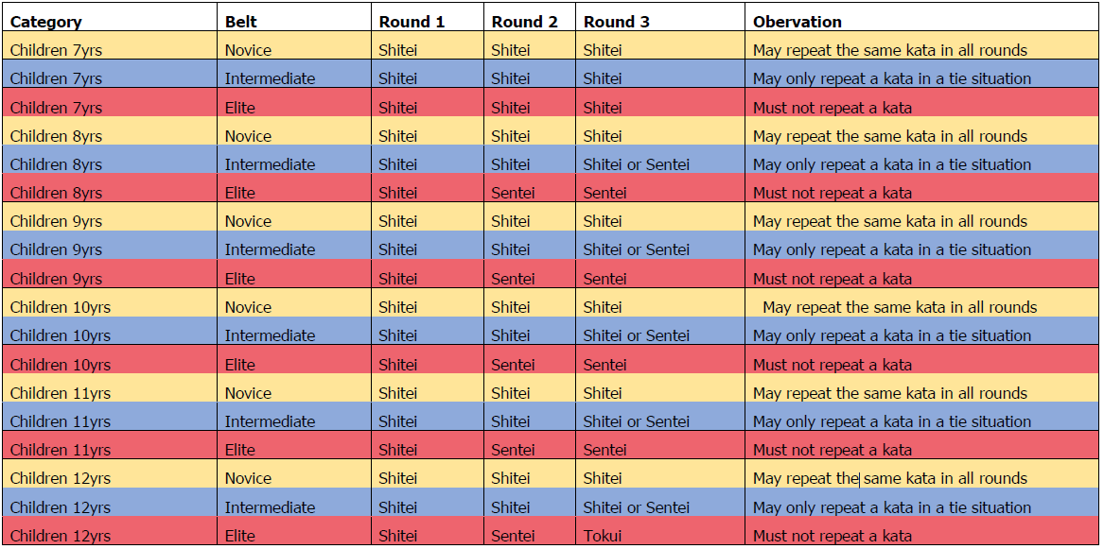

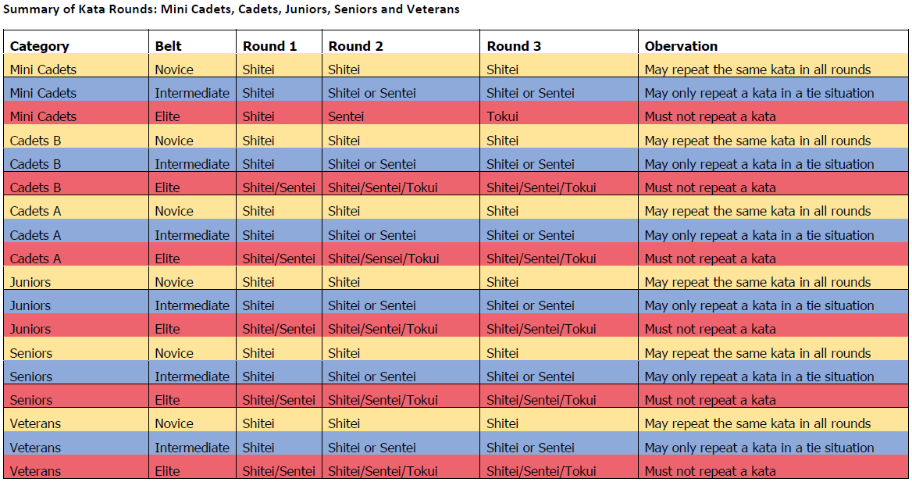

The term “Tokui” does not restrict to, but also allows competitors to select a Kata from the Shitei or Sentei group of Kata on the Official Kata Schedule. The meaning of “Tokui” is a Kata not performed previously. “Sentei” also includes “Shitei”.

No Kihon Kata or half of a Kata or Taikyoku allowed.
Only Kata on the “Official WUKF Kata list” and Gorin are permitted.

Please make sure, as far as possible, that your competitors (or with the help of a Coach) know which Kata they must perform in the different rounds and in the event of a TIE, which style they are entered under, and which Federation they represent.

Kobudo

Kobudo categories are judged in the same way as Kata categories.

- Kihon Kata and free choice Kata will be allowed.
- The Kata may be repeated in each round.
- Tapered Bo and variations will NOT be allowed.
- Athletes may not roll their sleeves up and must stick to the official dress rules for competitors.
- As per the WUKF Kobudo Rules, the Uniform (Karate-Gi) and rules on how to wear it, is the same as in the general rules, with the exception being that competitors can wear a black dogi jacket with white dogi pants.
- Competitors should be using the correct specified equipment as would be required for grading etc. The weapons should be correct as per the requirements.
- Weapons will be inspected, weighed and approved before the event.

Inclusive Karate

- Any Kata on the “Official WUKF Kata list” may be performed.
- Kata may be repeated in each round.
All competitors will perform at least 2 rounds of kata.
- The Rainbow adjustment system will be used in scoring the kata performance. The competitors will be classified by a member of the WUKF Inclusive Commission.
- Competitors must always, perform his/her Kata without outside assistance. Visually impaired competitors may be escorted onto and off the tatami, before and after their performance.
- The uniform is the same as in the general rules, except for the wearing of a white t-shirt under the Karate-Gi jacket by male competitors. The designated attacker’s uniform must comply to the Inclusive Combat rules.

TOGETHER WE CAN DO THE BEST KARATE IN THE WORLD

AND MAKE A SUCCESS OF THE TOURNAMENT.




