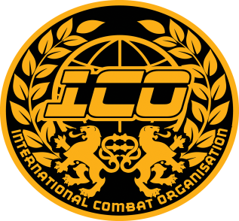
ICO RING CONTINUOUS RULES
Ring continuous rules and style of fighting are basically the same as Light contact and Full contact.
The main difference is that it is fought in the ring and the POWER is NOT light and NOT full.
The power level is CONTROLLED SAFE STRIKES to the head ESPECIALLY FOR 15YRS AND UNDER, heavier contact to the body is allowed but NOT! for TKO or KO!.

A standing count can ONLY be given to a fighter for poor conditioning, i.e a fighter not fit or in good shape! For the fight and NOT! For a knock down TKO or KO.

Warnings are 1 x verbal then YELLOW card Then RED card = disqualification but referee may use discretion and jump to any level he or her see fit.

The above warnings are for any foul breaking of rules or excess power.

A yellow card may result in a minus point should Referee deem fit!

Scoring is based on clean offensive hits to a legal target, but defence, ring craft, fitness, range of technique applied may also be taken into account.

The SCORING is on a 10-9 must system and offensive and defensive fighting is scored.
Winner of round will get 10 points.
Loser of round will get 9 points.
A drawn round will see 10 points each.
An 8 count for poor condition will result in a 8 point round for that fighter.
A minus point will reduce score accordingly.

Duration of rounds: Elimination style competitions.
Kids 12yrs & under = 2 x 1.5 min
Jnr 13-15yrs = 2 x 1.5 min
Cadet 16-18yrs = 2 x 1.5 min
Adult 19 -35yrs = 2 x 2 min
Adult 36yrs + Vets maters = 2 x 1.5 min
1 min rest may be used.
In event of a draw the 1 x extra round and decision must be made.
This may change on the day of competition at promoter’s discretion!
Gala event titles will be contested over 5 rounds and time duration is the same as age limit stated above.
Equipment required:
10 oz boxing gloves in good condition. (NO SMALL COMPRESSED 10 OZ GLOVES ALLOWED)
Kick boots that fit well and in good condition.
Shin pads.
Groin guard – Male and Female is advised.
Chest guard – Female advised.
Head guard – Open face and in good condition. (TOPTEN/SAP/ADDIDAS STYLE)
Gum shield.
Clothing:
Long kick boxing trousers:
Club T-shirt.
Club suit.
Scoring areas:
Front and side of head.
Front and side of the body.
Inside and outside boot of FRONT leg (sweep)
Cont….
Illegal technique:
Cart wheel kick.
Drop sweeps.
Grounded kick technique.
Knee or elbows.
Back Fist or Spinning back fist.
Low kick.
Bad or abusive behaviour or deliberate excessive power will result in immediate disqualification!

Legal technique:
All standard and widely recognised boxing and kicking techniques.

A continual kicking rule applies which means if a fighter tries to just box you will never win a fight! A good ratio of punch and kick must be maintained.

