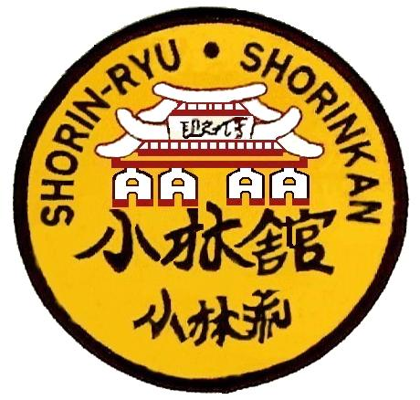

SHORIN - RYU SHORINKAN
NATIONALS 2025 - PRETORIA
___________________________________________________________________________________

COMPETITOR INFORMATION

NAME |  | MALE / FEMALE

DATE OF BIRTH |  | AGE
INSTRUCTOR |  | KARATE GRADE
CLUB |  | KOBUDO GRADE

CATEGORIES

I wish to enter the following Categories :

Championship : 2025 SHORIN-RYU SHORINKAN KARATE NATIONALS PRETORIA

Date : 10 – 11 October 2025 Venue : Jonnibach Hall, 377 Eufees street, Pretoria North

Tick Appropriate Box
Individual Kata |  | Shobu Nihon Kumite (12yrs and under)
Unison Kata |  | Shobu Sanbon Kumite (13yrs and over)
Kobudo – Long Weapons |  | Rotational Kumite
Kobduo Short Weapons
Kata – Opens Division (Black Belts only) |  | Kumite – Opens Division (Black Belts only)

INDEMNITY AND CONSENT FORM FOR THE SHORIN-RYU SHORINKAN SA NATIONAL CHAMPIONHIP – 2025 PRETORIA
I, the undersigned, in my capacity as the father / mother / guardian / my own personal capacity, do hereby indemnify and hold harmless SHORIN-RYU KARATE SA, the organizers or anyone else associated in any way with this event from death, injury, disability and from all claims, causes of action, losses, damages, costs, expenses (including but not limited to attorney’s fees), either known or unknown, now existing or arising in the future that I / my child(referenced below) may have of any kind or nature, how so ever arising (including but not limited to negligence on the part of any members of SHORIN-RYU KARATE SA, the organizers or anyone else associated in any way with this event),and which I / my child (referenced below) may suffer as a result of my / his / her participation in the SHORIN-RYU SHORINKAN NATIONAL CHAMPIONSHIP held in Pretoria on the 10-11 October 2025.
I acknowledge that participation by myself / my child (referenced below) in this event is by my / his/ her own free will and at my / his / her own risk. By agreeing to and by participating in this event I, the undersigned, in my capacity as the father / mother / guardian / my own personal capacity, do hereby confirm that I am aware of and voluntarily accept the risks associated with the events offered in this karate tournament.
Whilst SHORIN-RYU KARATE SA, the organizers or anyone else associated in any way with this event, will strive to ensure the safety of participants is a priority, I acknowledge that SHORIN-RYU KARATE SA, the organizers or anyone else associated in any way with this event shall not be held liable for claim which I may otherwise have had and I fully indemnify SHORIN-RYU KARATE SA, the organizers or anyone else associated in any way with this event against the above eventualities both in my personal and representative capacity.
I also agree that any pictures / material taken of me / him / her in connection with the event can be used by SHORIN-RYU KARATE SA for publicity or promotion without compensation to me / him / her.
I acknowledge and agree that my / his / her membership with SHORIN-RYU KARATE SA is current and that I am currently a registered member of SHORIN-RYU KARATE SA. I will be bound by the rules of the event.

_____________________ ________________________________ _________________________

(Signature of Competitor) Signature of Parent / Guardian if under 18yrs) (Date)

