
Equipment & Clothing required at WC 2024

K1 FULL
10 OZ BOXING GLOVES
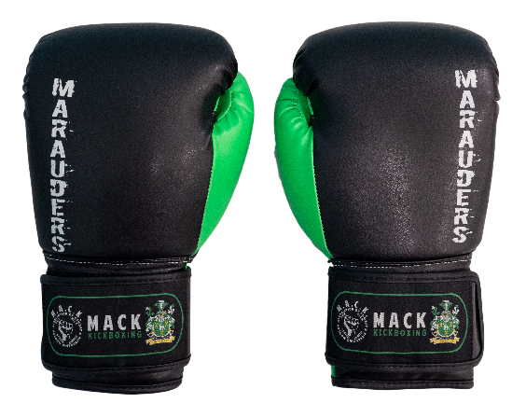
SHIN AND INSTEP PROTECTORS
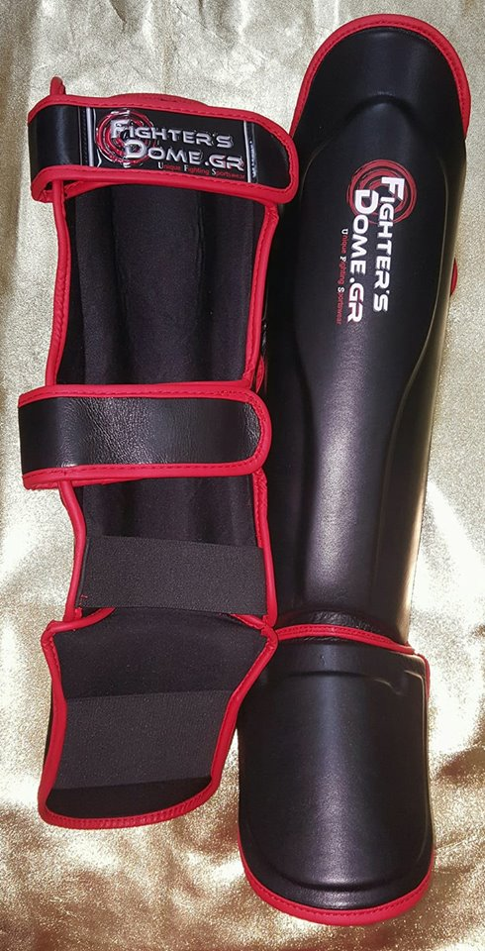
HEAD GUARD
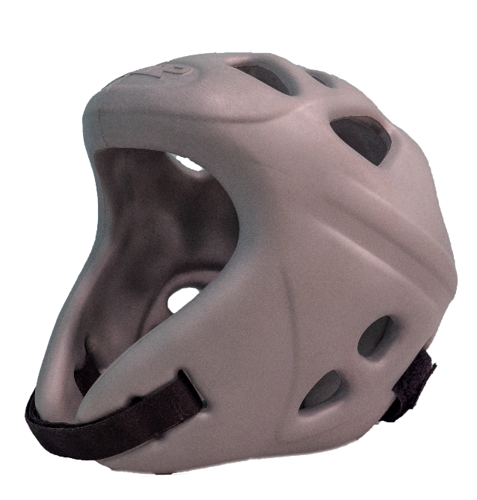
MOUTH GUARD
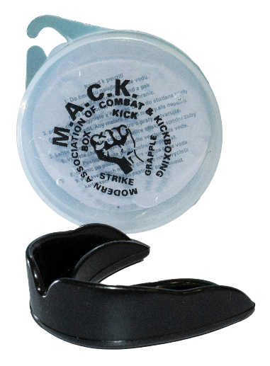
GROIN GUARD
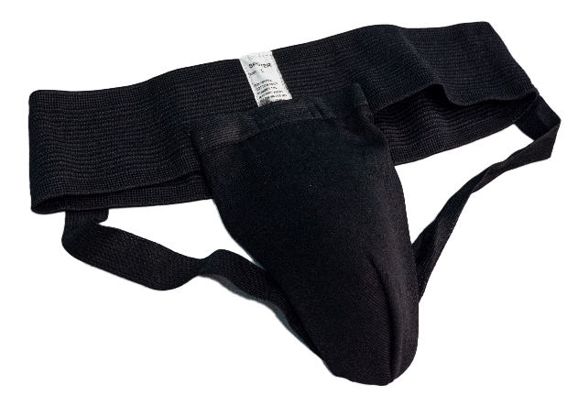
SHORTS
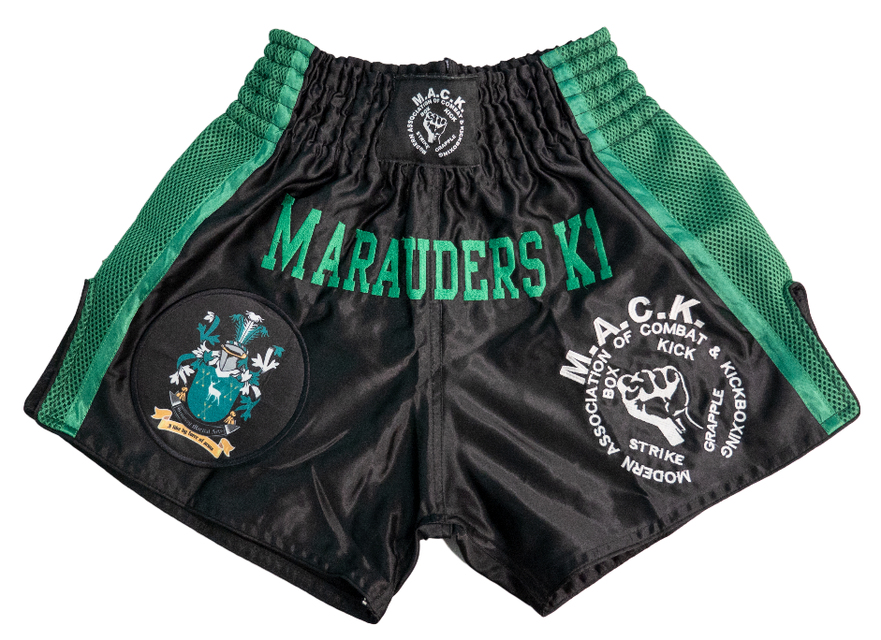

LADIES INC. TOP AND CHEST PROTECTOR!

K1 CONTINUOUS (K1 LIGHT)
AS ABOVE BUT!

T SHIRT MUST BE WORN
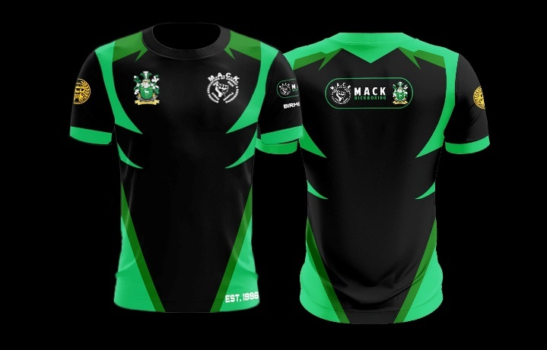

15 YRS AND UNDER MUST WEAR BODY ARMOR
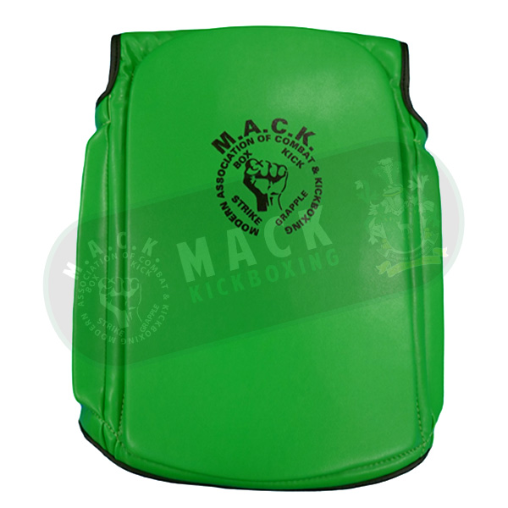

KICK LIGHT (LOW KICK)
10 OZ BOXING GLOVES

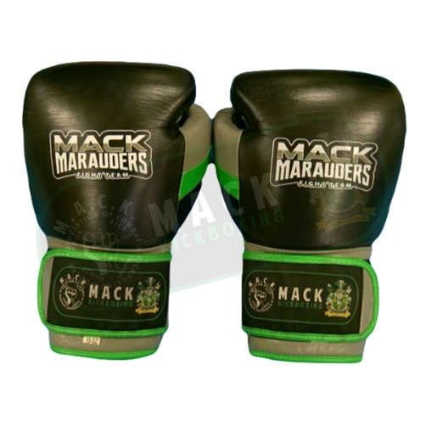
KICK BOOTS
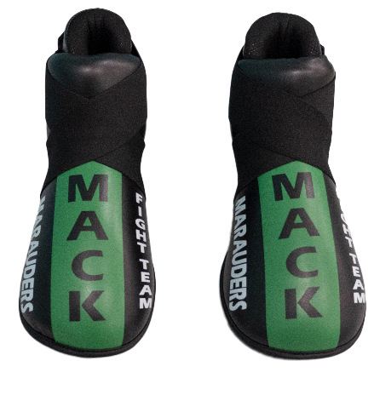

SHIN PADS
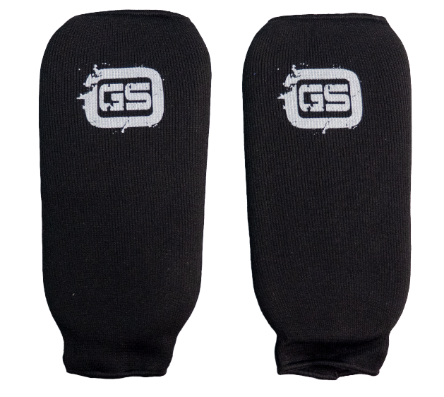
HEAD GUARD
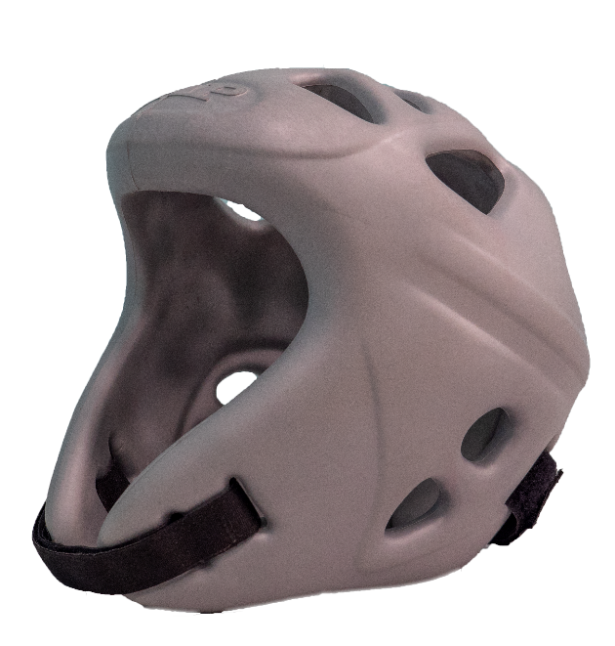
MOUTH GUARD
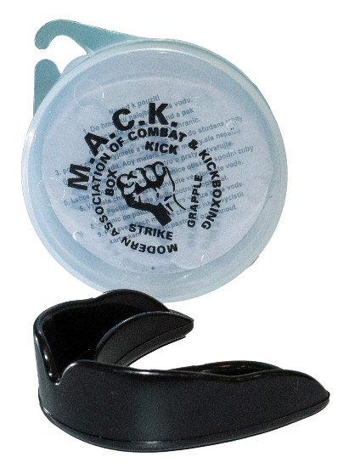
GROIN GUARD
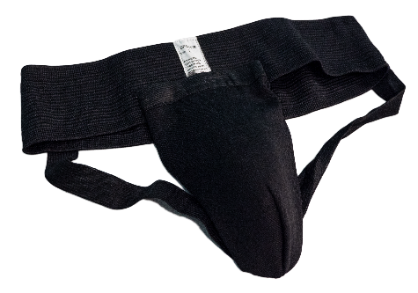
CHEST GUARD ADVISORY FOR FEMALES!

SHORTS
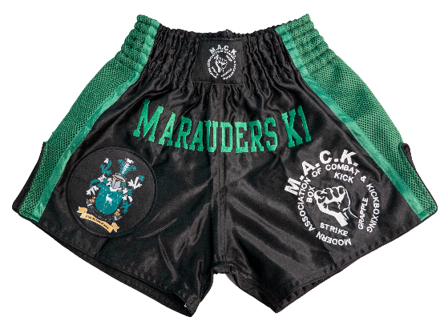
T SHIRT
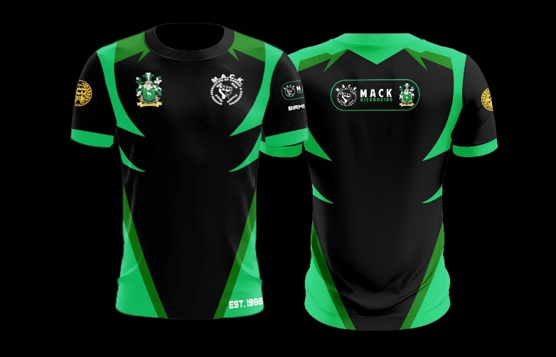

BOX LIGHT AND BOX FULL
10 OZ BOXING GLOVES
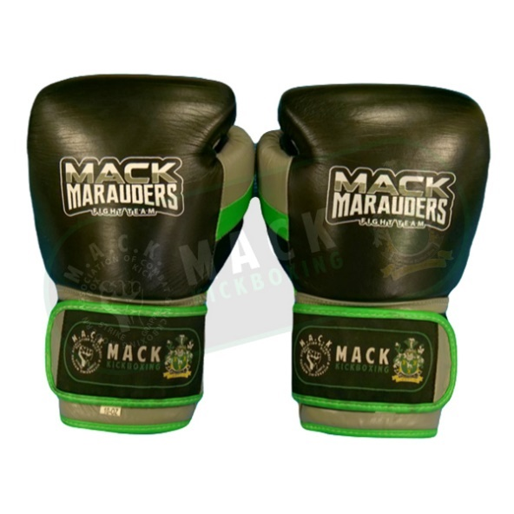
HEAD GUARD
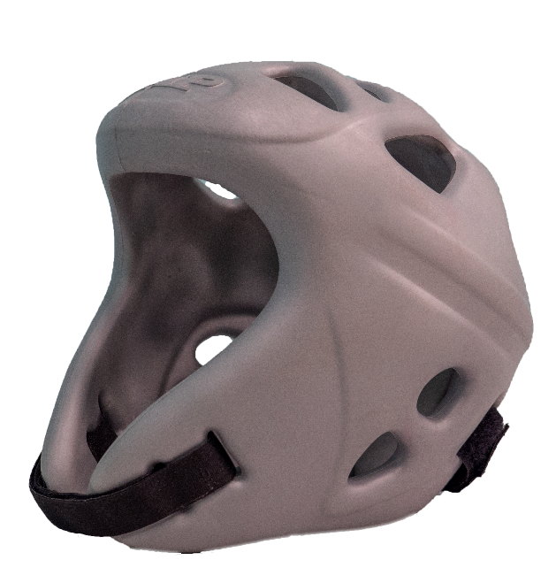
MOUTH GUARD
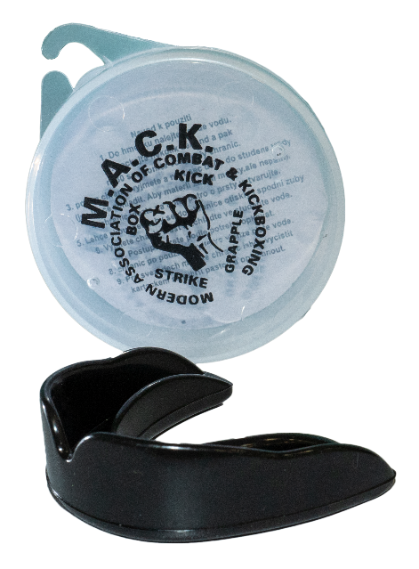
GROIN GUARD
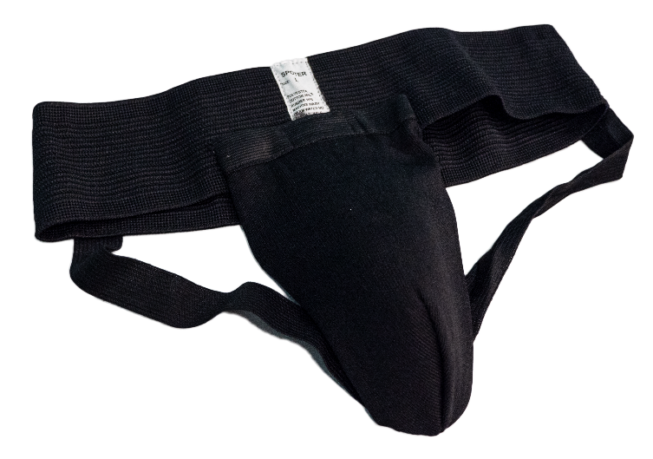
CHEST GUARD ADVISORY FOR FEMALES!
SHORTS
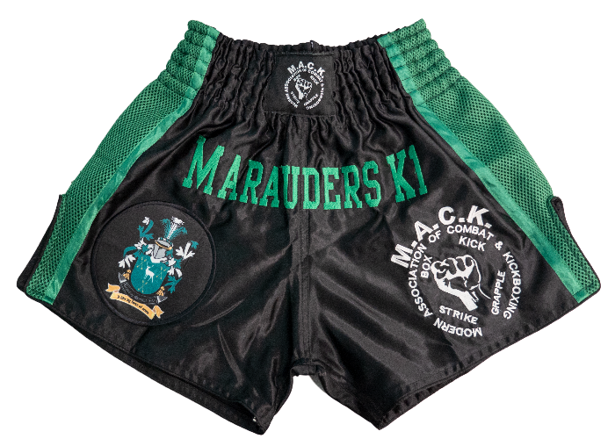
T SHIRT/BOX FULL NO T SHIRTS FOR MALES
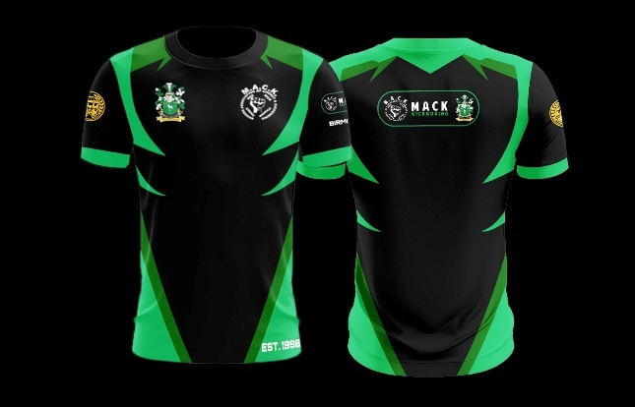

THAI BOXING
10 OZ BOXING GLOVES
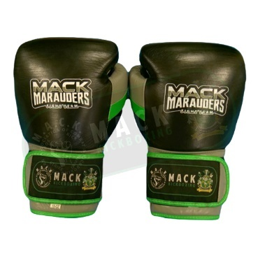
SHIN AND INSTEP PROTECTORS
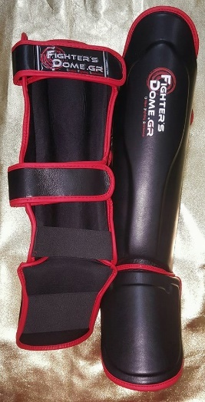
HEAD GUARD
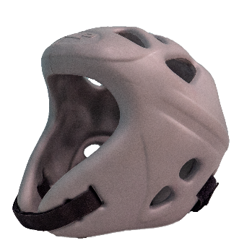
ELBOW PADS
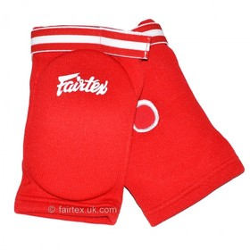

MOUTH GUARD

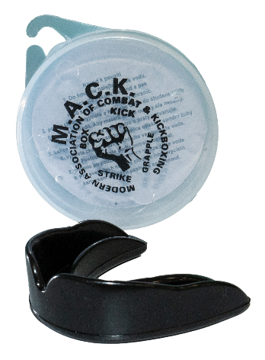
GROIN GUARD
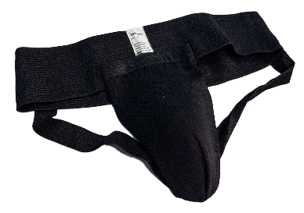
CHEST GUARD AND TOP FOR FEMALES!

SHORTS
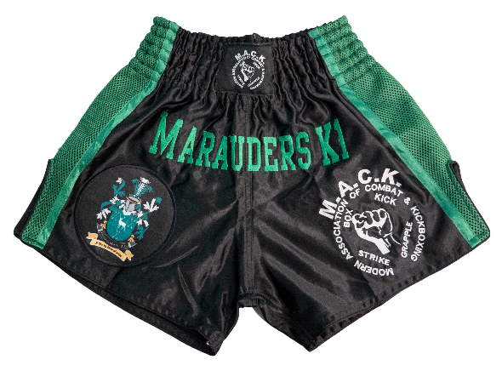
SUBSTRIKE FULL
7 OZ GRAPPLE AND STRIKE GLOVES
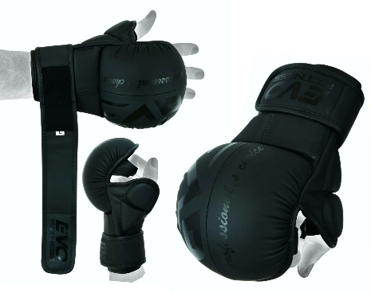
SHIN AND INSTEP PROTECTORS
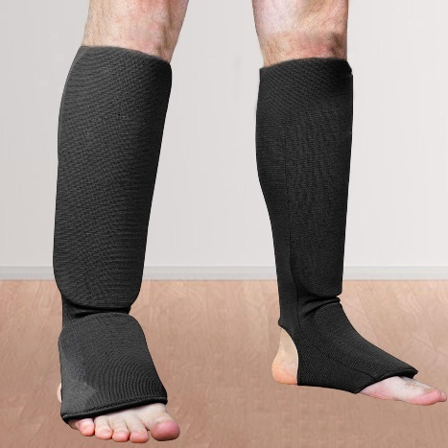
MOUTH GUARD
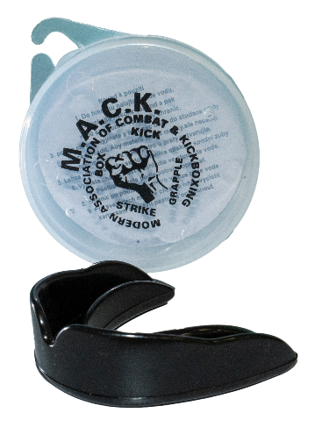
GROIN GUARD
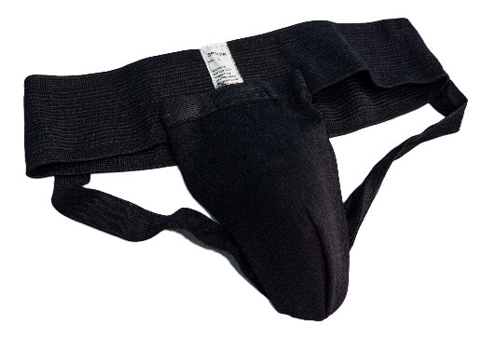
CHEST GUARD AND TOP FOR FEMALES!
SHORTS
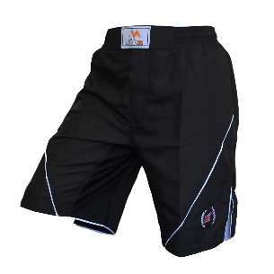NO HEAD GUARD DUE TO GRAPPLING!
LIGHT CONTACT/RING CONTINUOUS/FULL CONTACT

10 OZ BOXING GLOVES
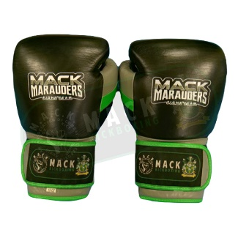
KICK BOOTS
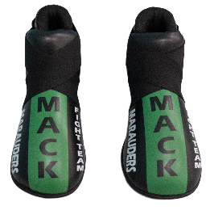
SHIN PADS
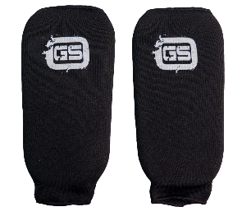
HEAD GUARD
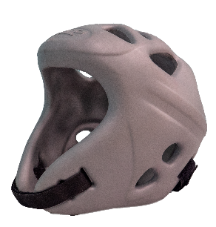
MOUTH GUARD
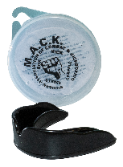
GROIN GUARD
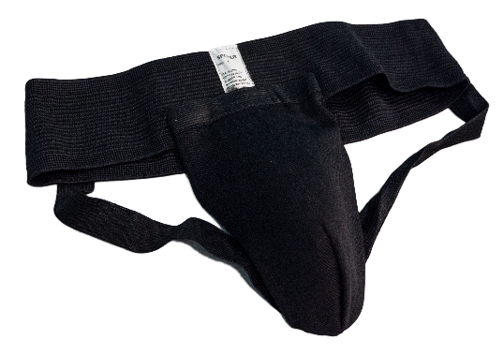
CHEST GUARD AND TOP IN FC FOR FEMALES!
LONG KB PANTS
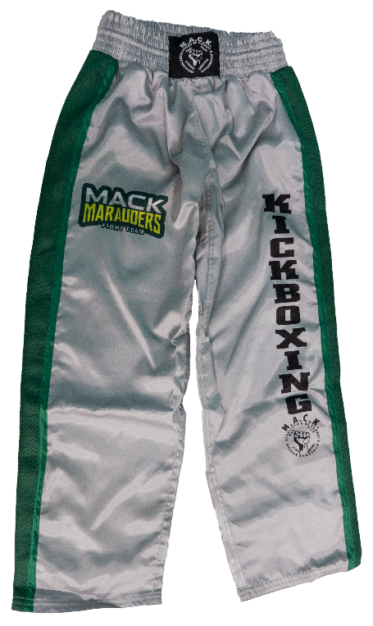

T SHIRT
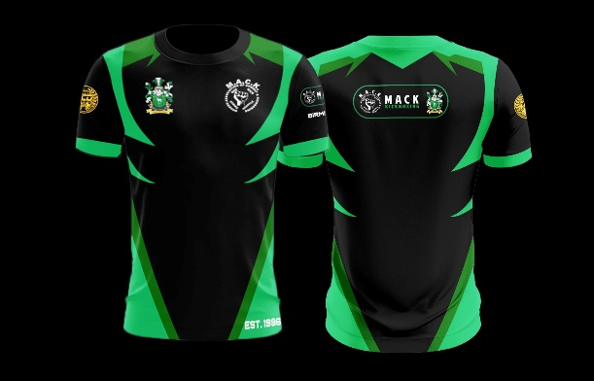
NO TOPS FOR MALES IN FC!

POINT FIGHTING

OPEN PALM POINT FIGHT GLOVE
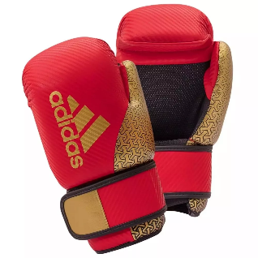
KICK BOOTS
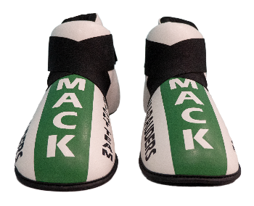
SHIN PADS
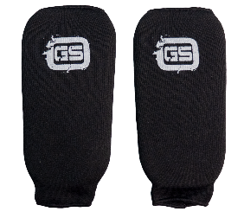
HEAD GUARD
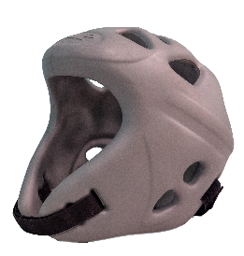
MOUTH GUARD
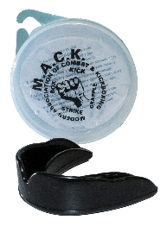
GROIN GUARD
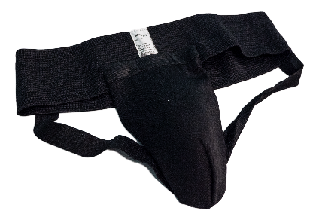
CHEST GUARD ADVISORY FOR FEMALES!

LONG KB PANTS
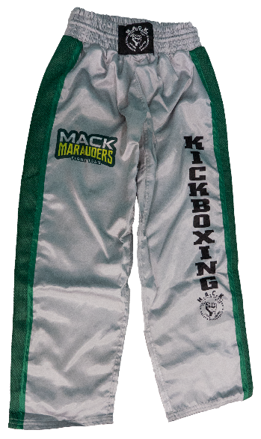
T SHIRT
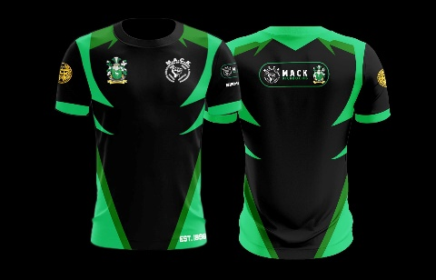
POINT FIGHT SUIT MAY ASLO BE WORN.

KARATE KUMITE

STANDARD KUMITE MITTS AND FOOT/SHIN PROTECTORS
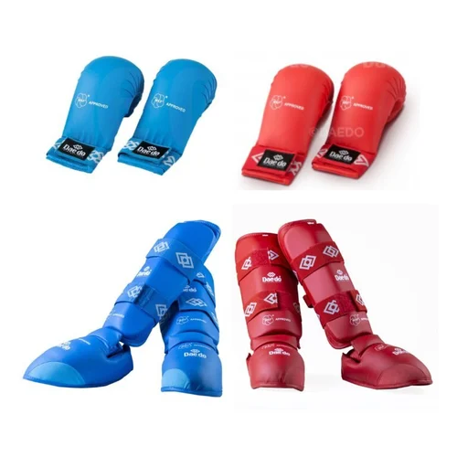
MOUTH GUARD
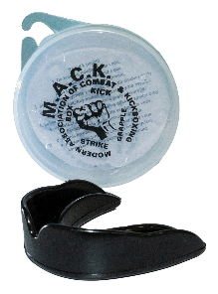
GROIN GUARD
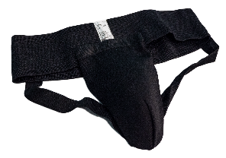
CHEST GUARD ADVISORY FOR FEMALES!
HEAD GUARDS 12YRS AND UNDER ONLY!
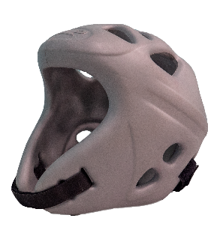
PLAIN TRADITIONAL KARATE SUIT CLUB BADGE ONLY!
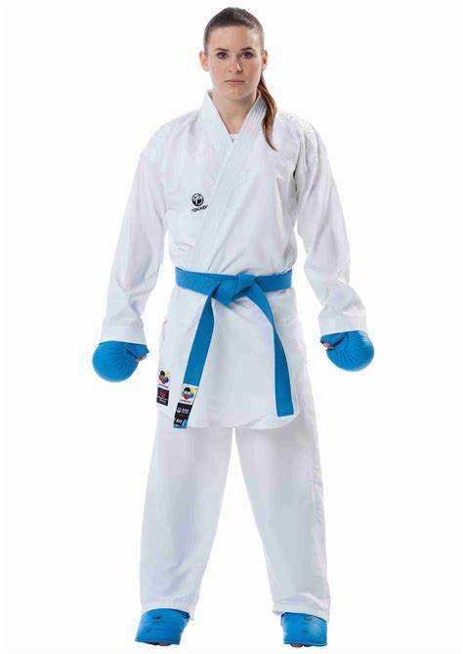
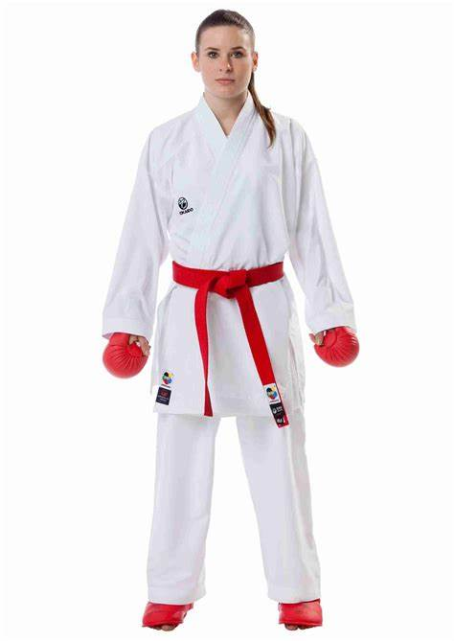
NO GI GRAPPLING
RASH GUARD SHORT OR LONG SLEEVES
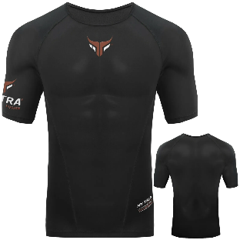
SHORTS
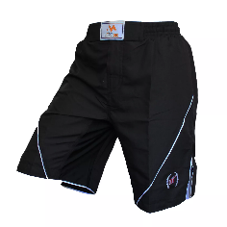
LEGGINGS MAY BE WORN
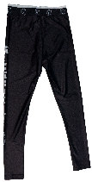
MOUTH GUARD
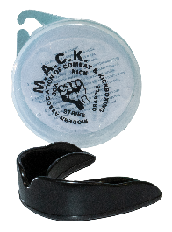
GI ON GRAPPLING
STANDARD BJJ / JUDO GI
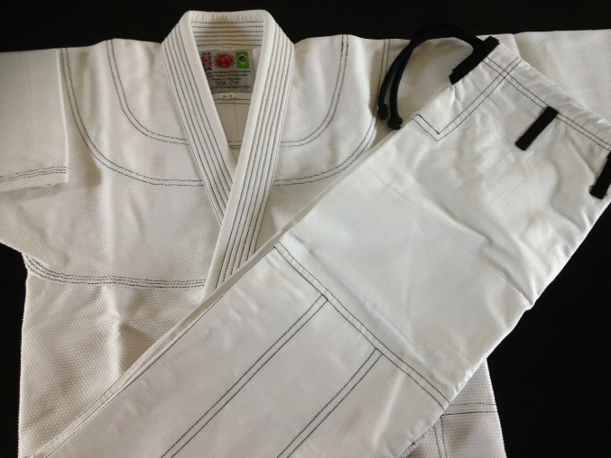

MOUTH GUARD
